Order Management

- Order.Api is running on http://localhost:5280
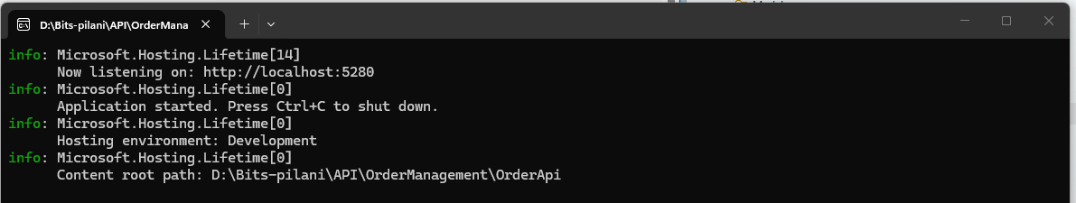

- OrderAPI is up and running from Visual Studio
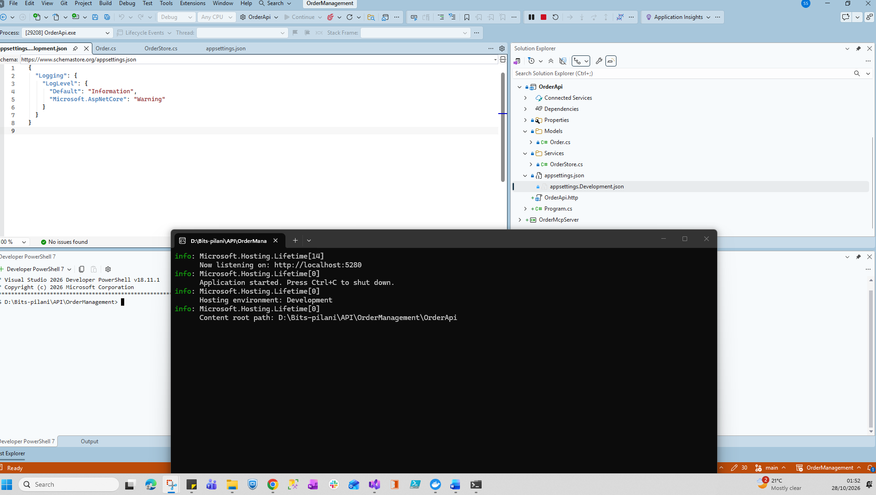

- Tested API in Visual Studio Terminal
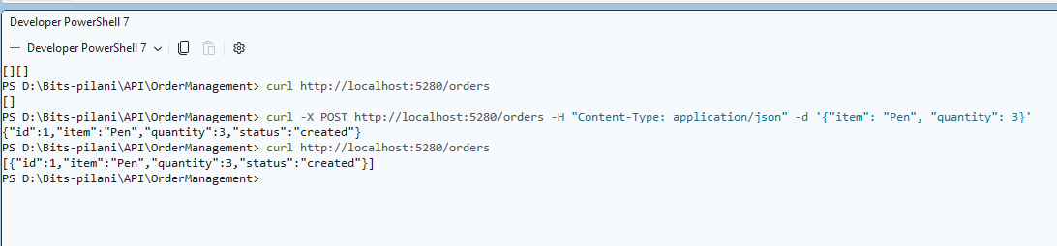
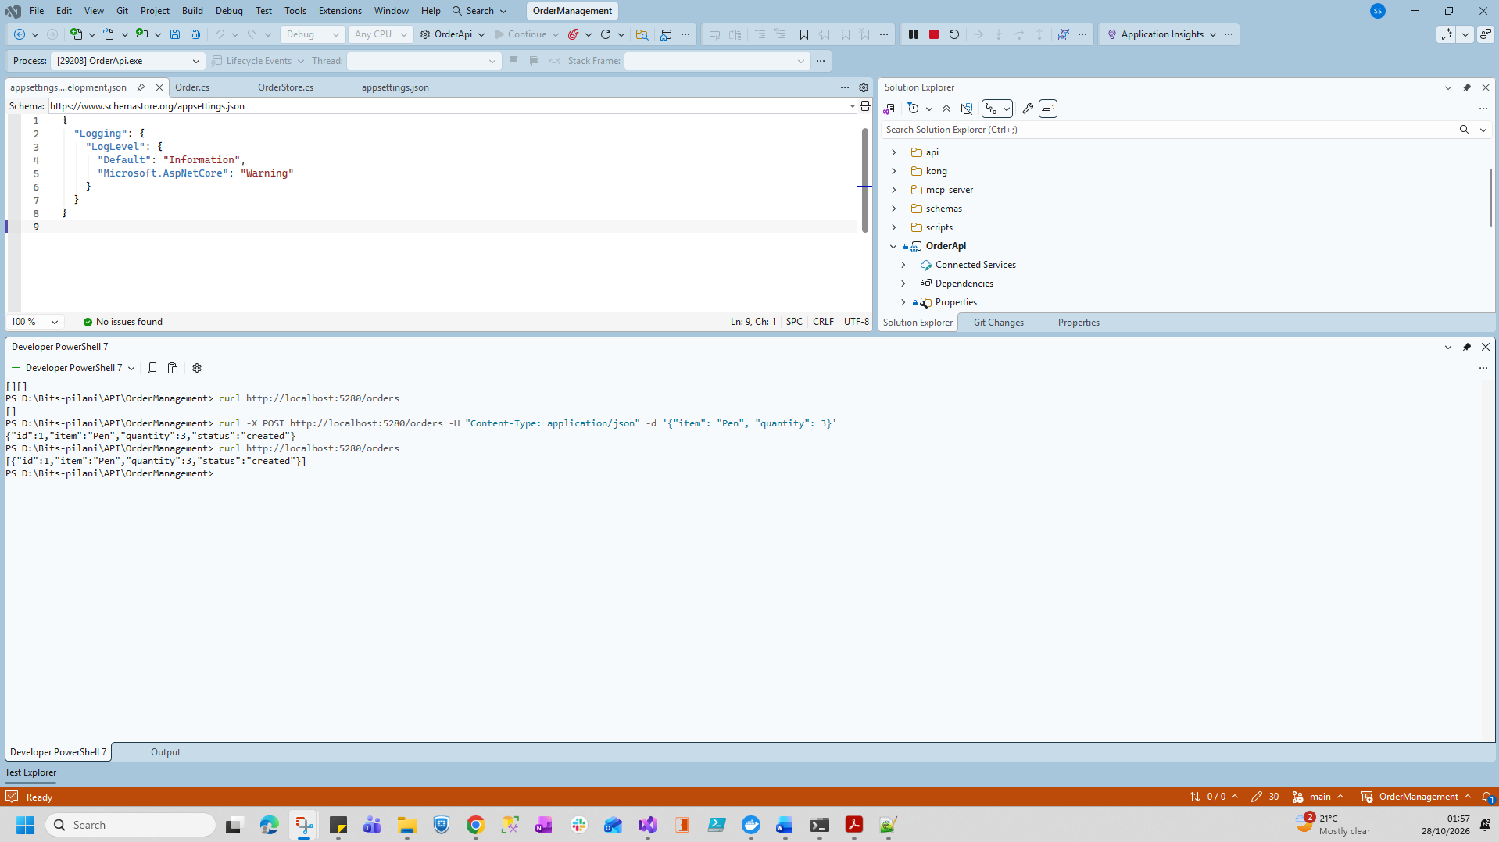

- Start Kong and docker compose file
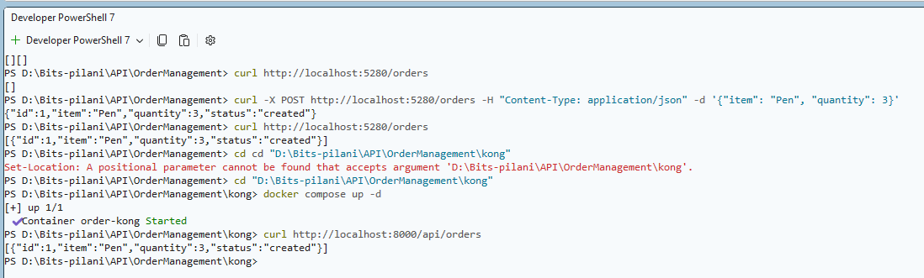

- Rate Limit Testing
Powershell Execution Logs

PS D:\Bits-pilani\API\OrderManagement\kong> cd "D:\Bits-pilani\API\OrderManagement\scripts"
PS D:\Bits-pilani\API\OrderManagement\scripts> cd "D:\Bits-pilani\API\OrderManagement\scripts"
PS D:\Bits-pilani\API\OrderManagement\scripts> .\demo-rate-limit.ps1
Hitting http://localhost:8000/api/orders (rate limit: 5 requests/minute)
Request 1 : 200
Request 2 : 200
Request 3 : 200
Request 4 : 200
Request 5 : 200
Request 6 : 429
{
"message": "API rate limit exceeded",
"request_id": "2f4b084ce9a8e4723203b878d23d3709"
}
Request 7 : 429
{
"message": "API rate limit exceeded",
"request_id": "9e4fd75a9f3c20554665ed47caf10932"
}
Request 8 : 429
{
"message": "API rate limit exceeded",
"request_id": "962a9607b497a1106be2fb4e027f633e"
}
PS D:\Bits-pilani\API\OrderManagement\scripts>

Powersheel execution Result:
